**LAB ACTIVITY – 4**

NAME: S.C.JAGADESH VARMA

REG NO: 192110565

1.Develop a system using UML for Recruitment System, to recruit the applicant for a particular job in the company. It was controlled by the central management system to manage the details of the particular applicant who has to be recruited by a Company.

USE CASE DIAGRAM:

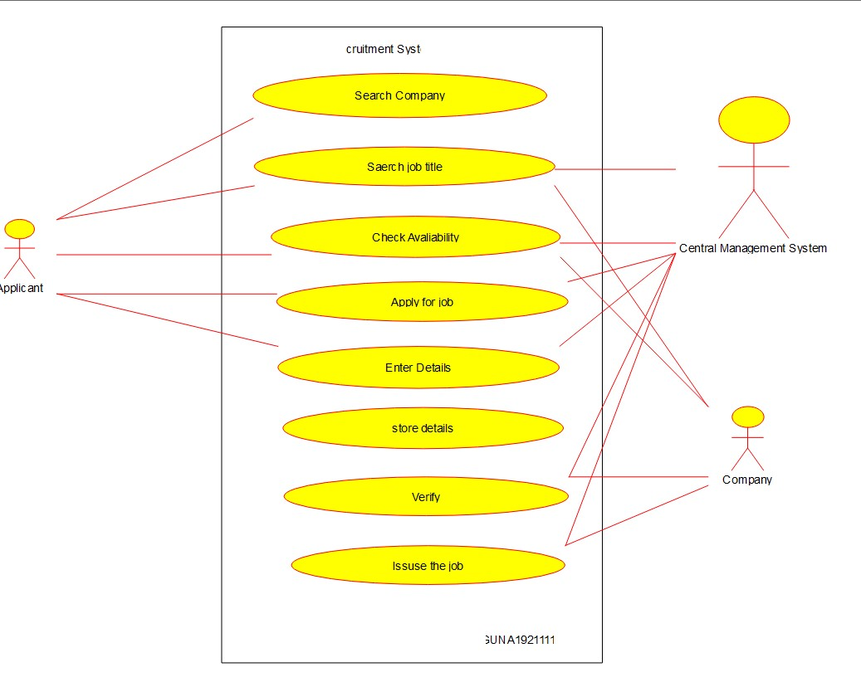

CLASS DIAGRAM:

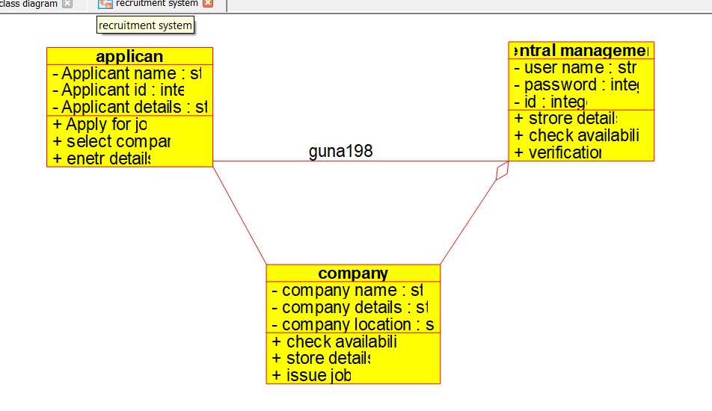

ACTIVITY DIAGRAM:

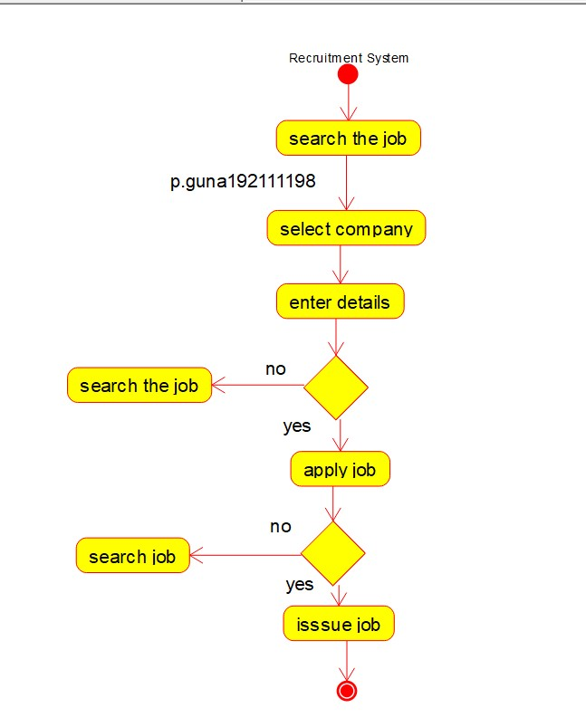

SEQUENCE DIAGRAM :

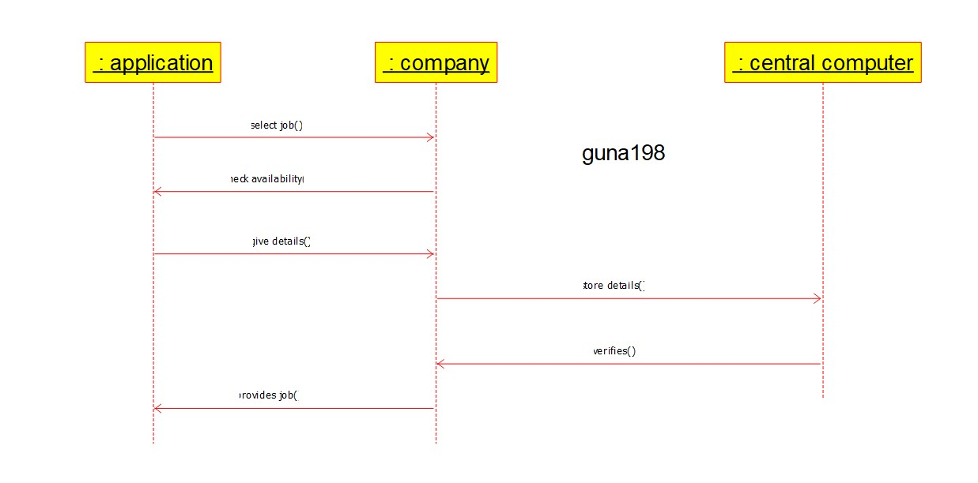

COMPONENT DIAGRAM :

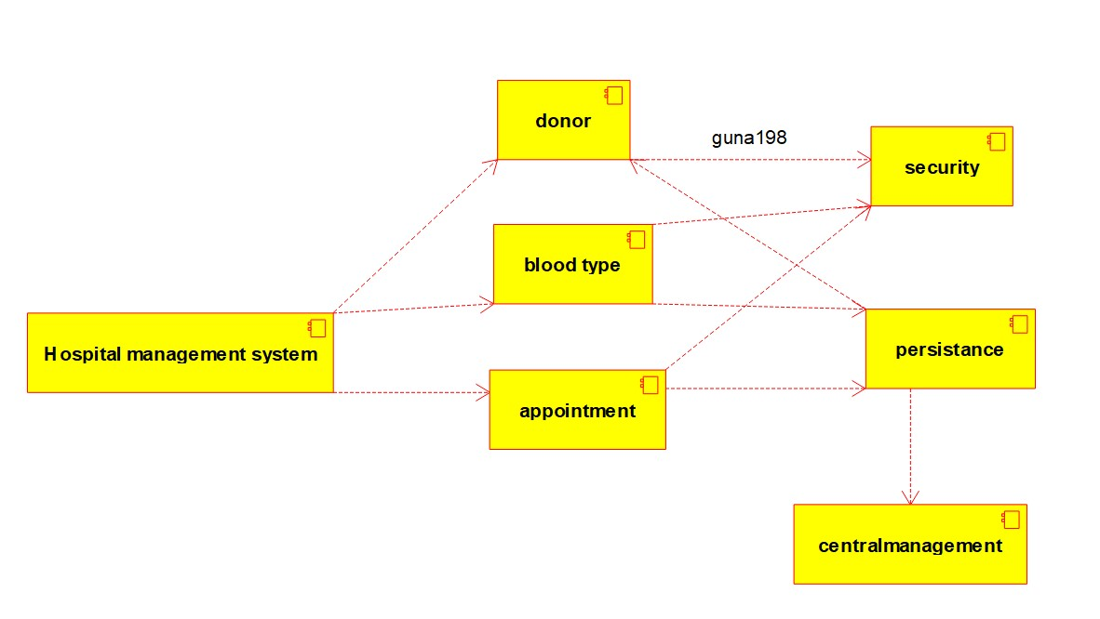COLLABARATION DIAGRAM:

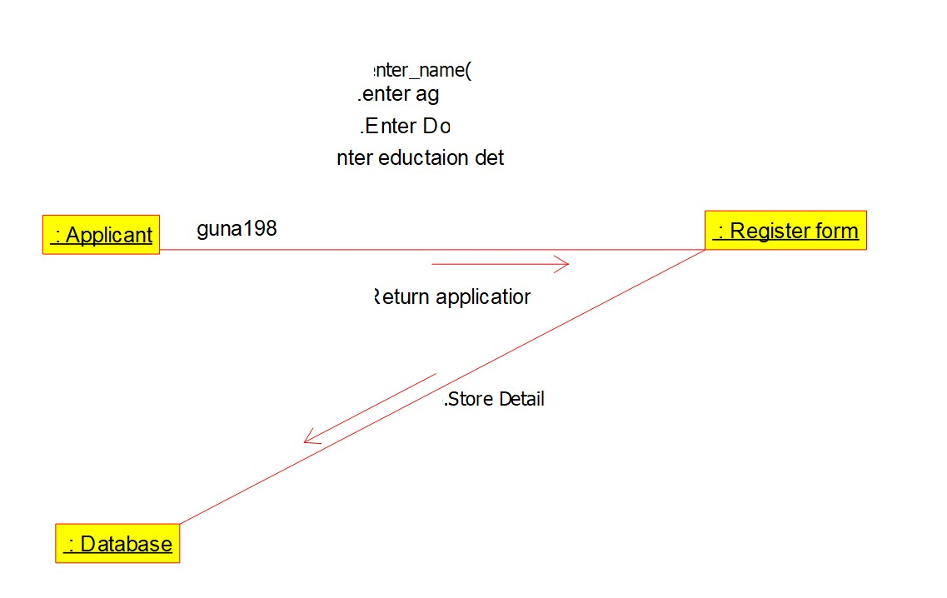

DEPLOYMENT DIAGRAM :

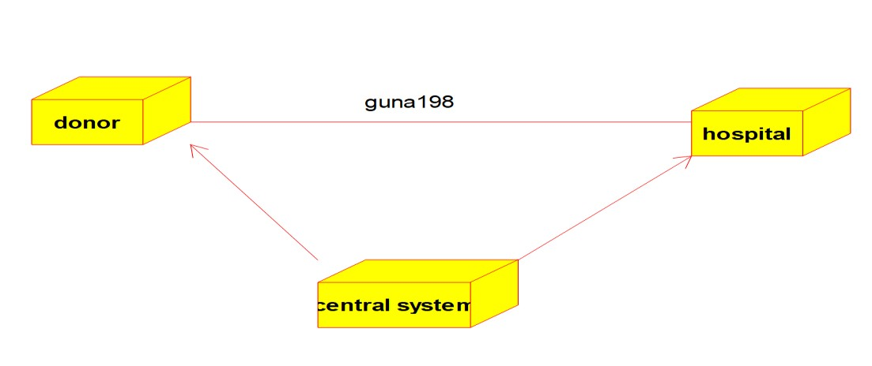

STATE CHART DIAGRAM :

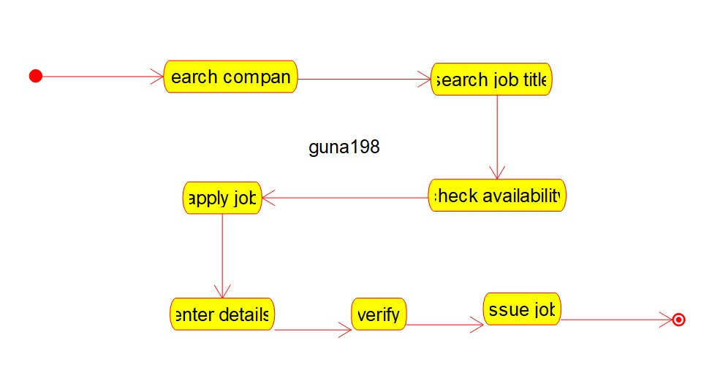

ER-DIAGRAM :

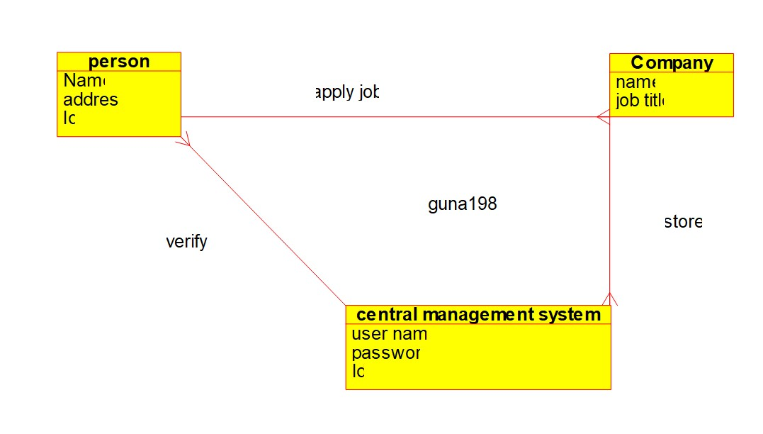

1. Develop a system using UML for Blood Bank Registration System. The system should have the list of donors and the hospitals can check for the donor's availability and get their appointment. The donor and the hospital can interact with the \central system.

USE CASE DIAGRAM :

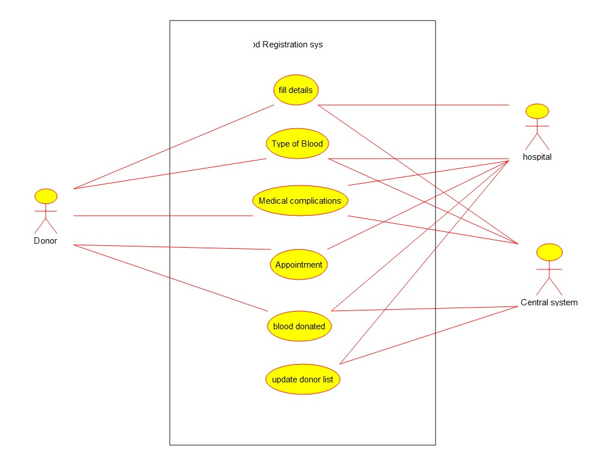

CLASS DIAGRAM :

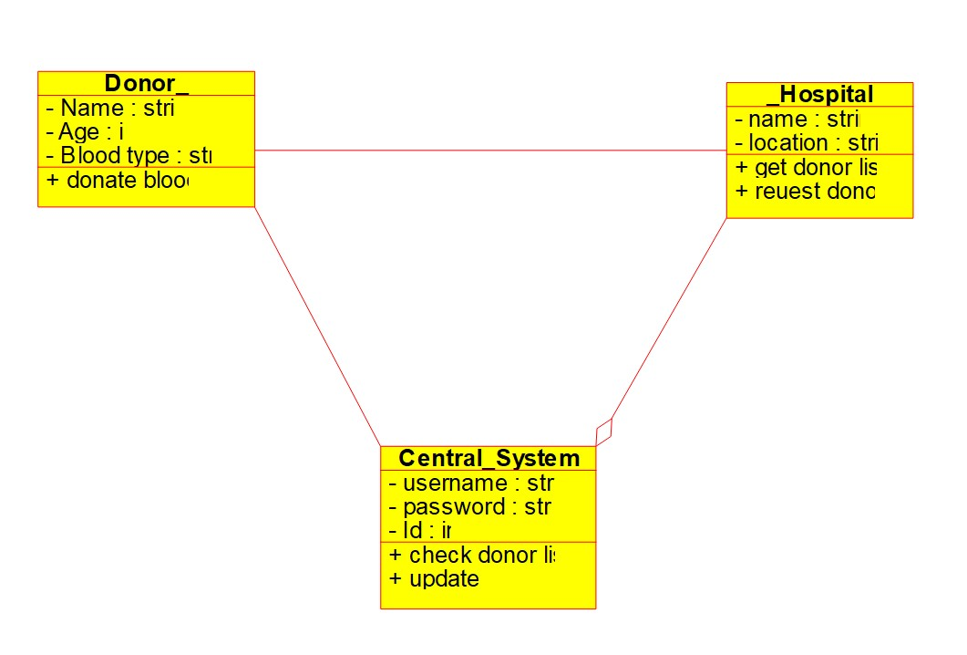

ACTIVITY DIAGRAM :

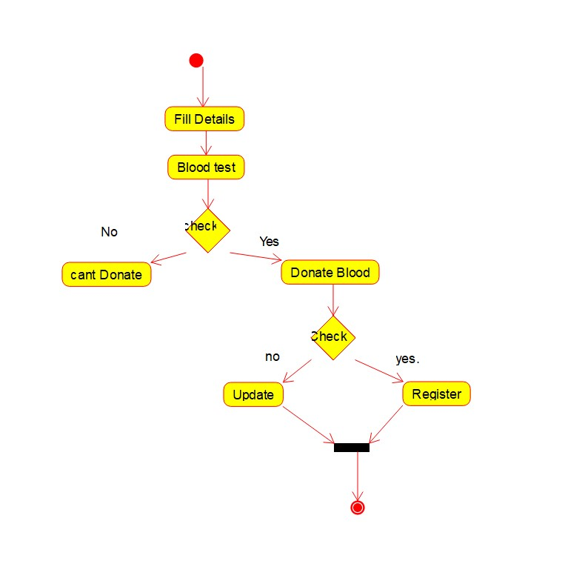

SEQUENCE DIAGRAM:

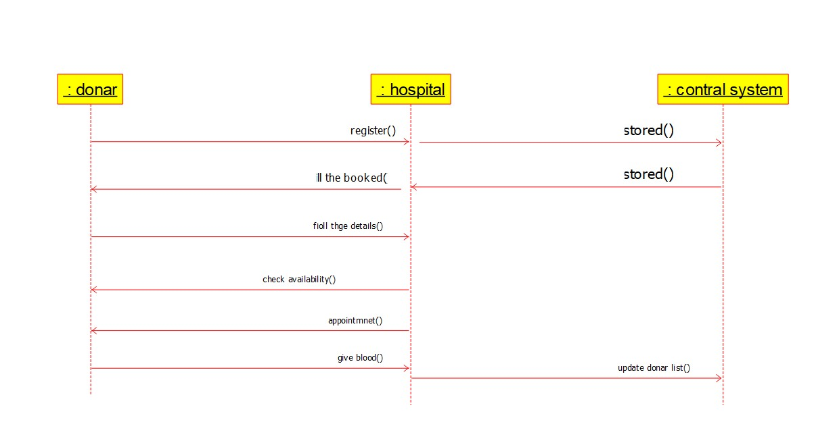

COLLABARATION DIAGRAM :

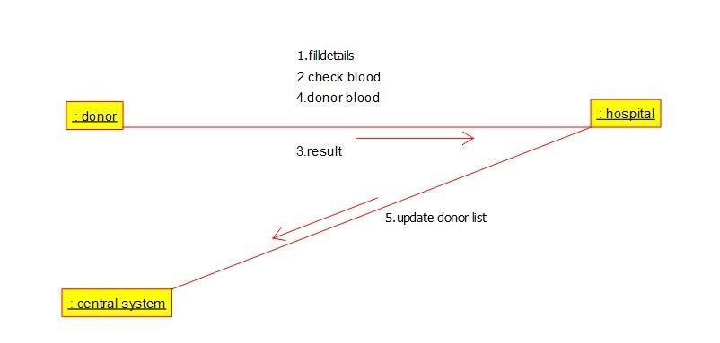

COMPONENT DIAGRAM :

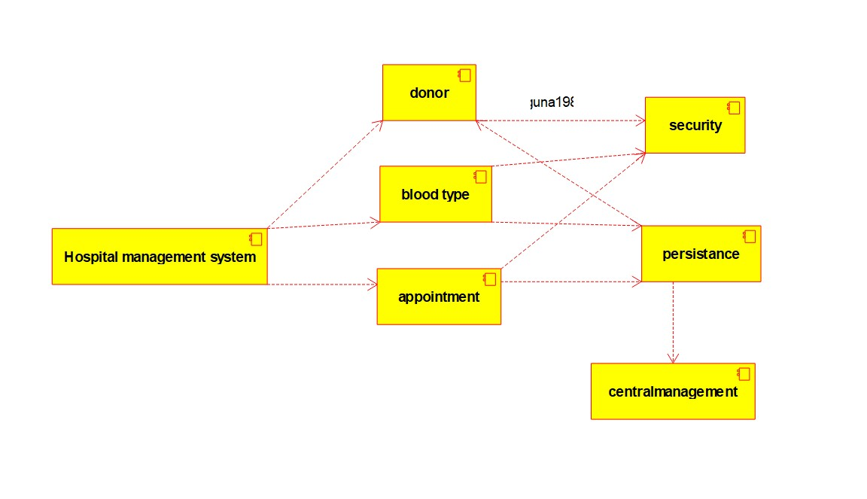

DEPLOYMENT DIAGRAM :

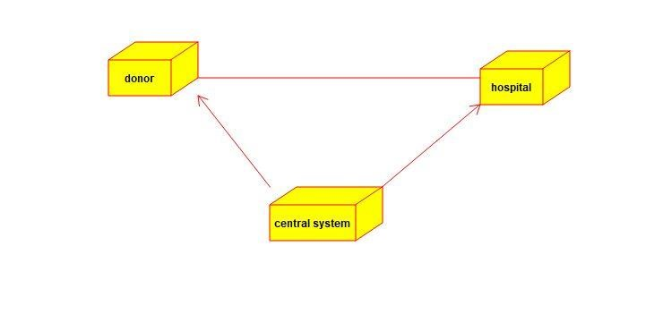

STATE CHART DIAGRAM :

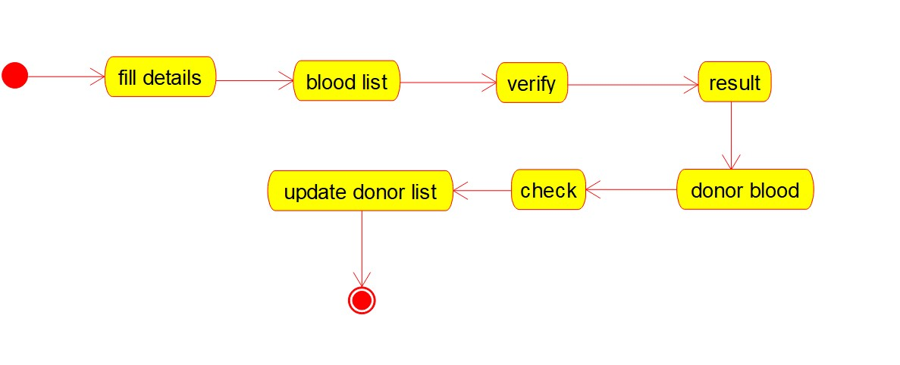

ER-DIAGRAM :

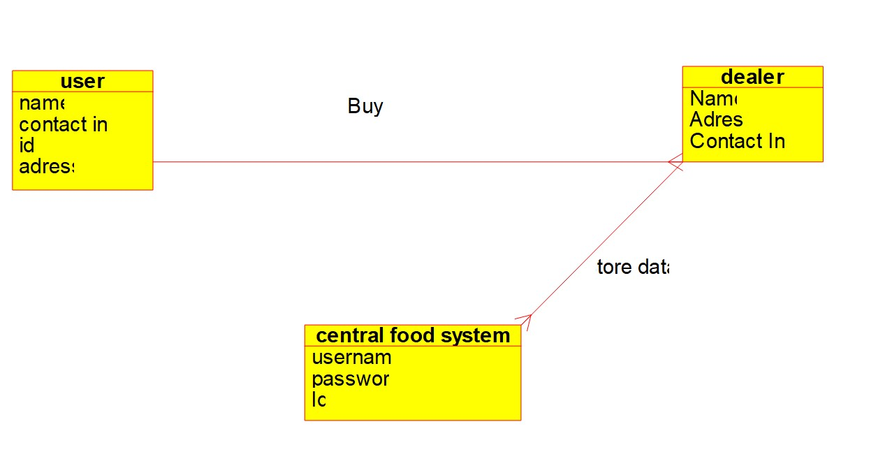

3.

Develop a system using UML for Food Order System. In this system, the customer can place orders and purchase items with the aid of the dealer and central food system. These orders are verified, and the items are delivered to the customer.

USE CASE DIAGRAM :



CLASS DIAGRAM :

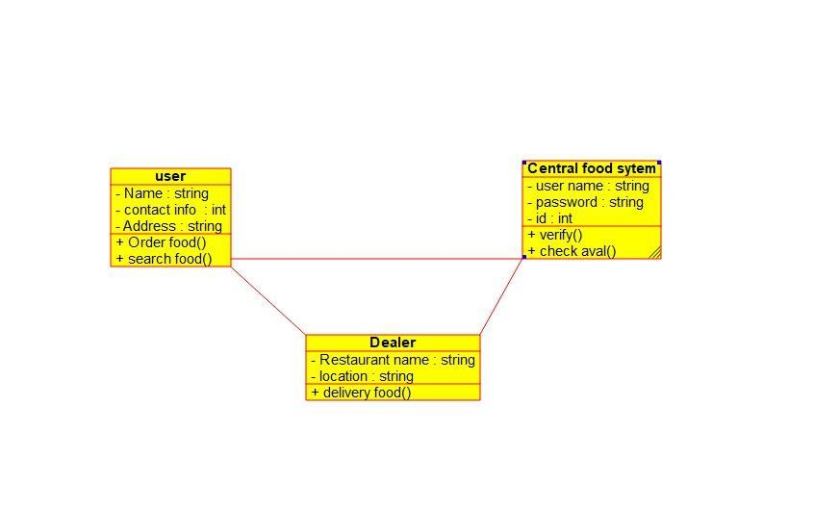

ACTIVITY DIAGRAM :

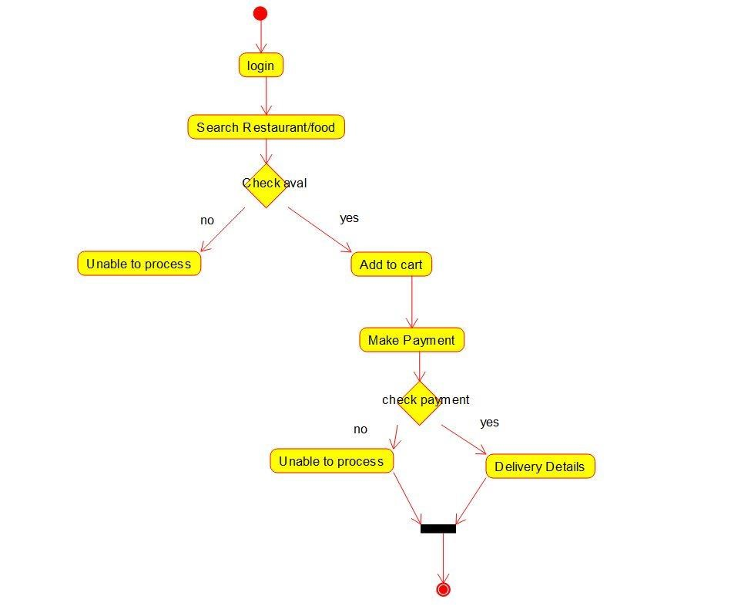

SEQUENCE DIAGRAM :

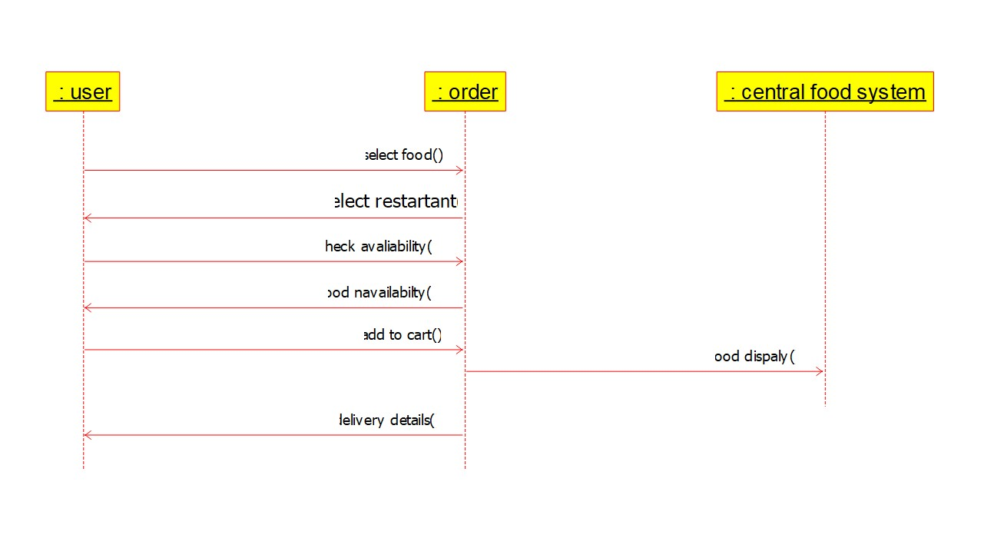

COLLABARATION DIAGRAM :

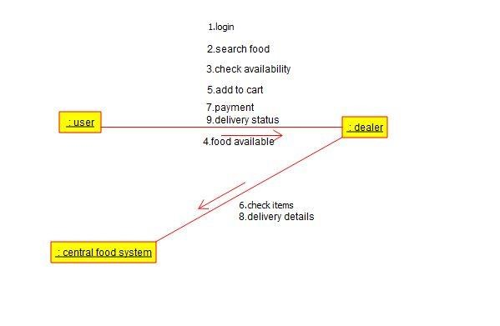

COMPONENT DIAGRAM :

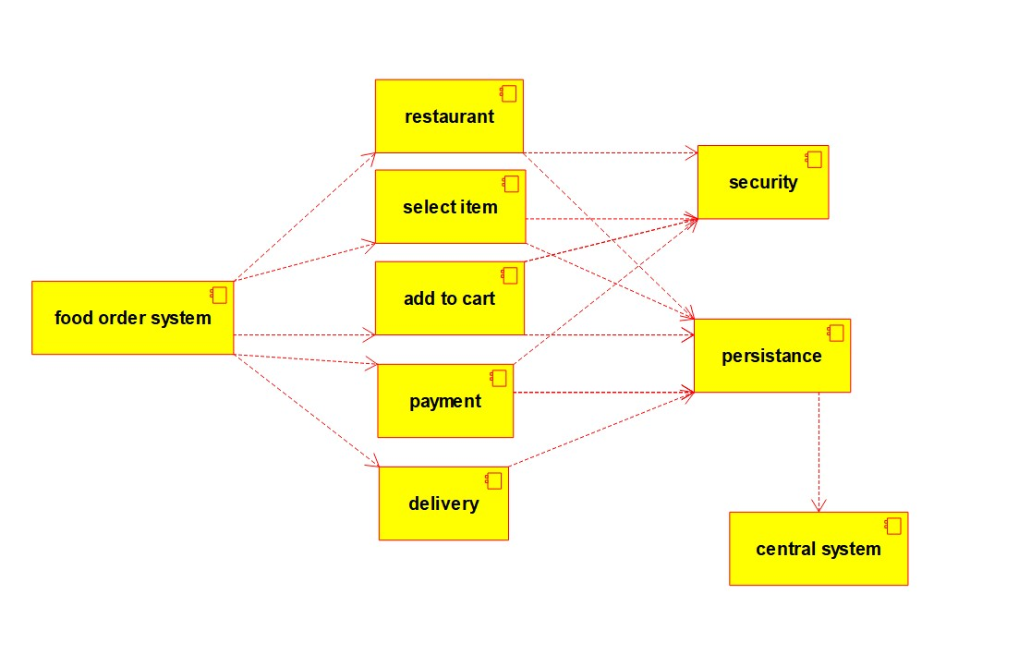

DEPLOYMENT DIAGRAM :

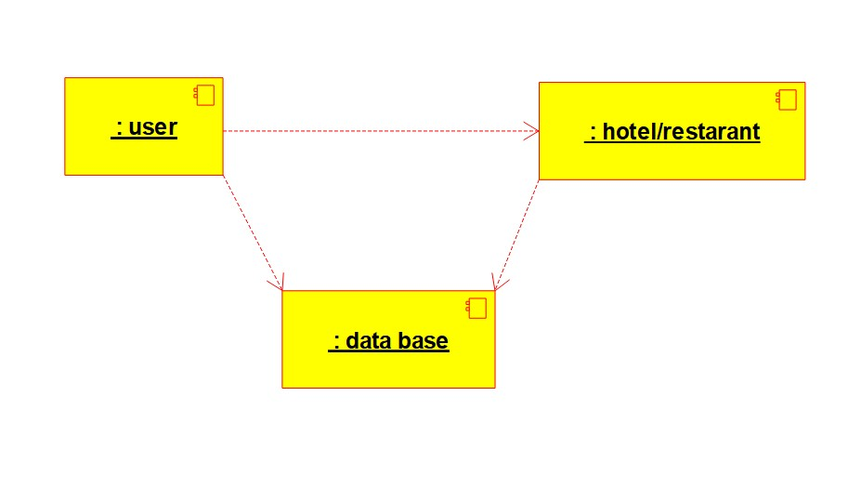

STATE CHART DIAGRAM:

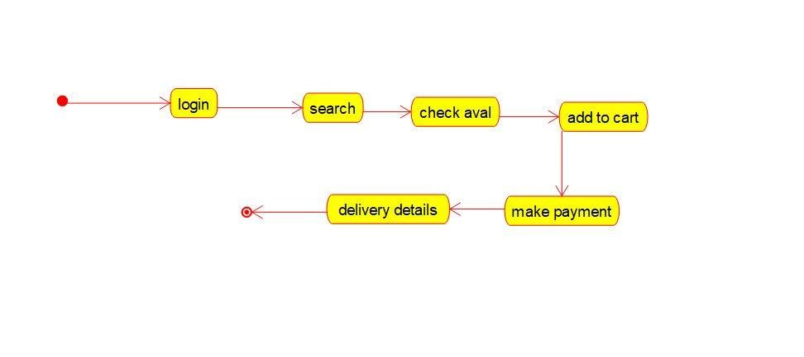

ER-DIAGRAM :

